Virtual Classroom (Vlass)

High Level Design

COP 4331C, Fall, 2015

## **Modification History**

|  |  |  |  |
| --- | --- | --- | --- |
| Version | Date | Who | Comment |
| V0.0 | 10/15/2015 | J. Casserino | Initial Draft |

Team Name: Group 26

Team Members:

Joseph Bender [jbender94@knights.ucf.edu](mailto:jbender94@knights.ucf.edu)

Joshua Casserino [Joshua.casserino@knights.ucf.edu](mailto:Joshua.casserino@knights.ucf.edu)

Chad Armstrong [chad.armstro@knights.ucf.edu](mailto:chad.armstro@knights.ucf.edu)

Miles Friedman [milesfriedmanfl@gmail.com](mailto:milesfriedmanfl@gmail.com)

Contents of this Document

High-Level Architecture........................................................................................................

Design Issues........................................................................................................................

**High-level Architecture**

* <Provide a diagram of the major components of your system and their interfaces. >
* <Describe each interface in detail.>

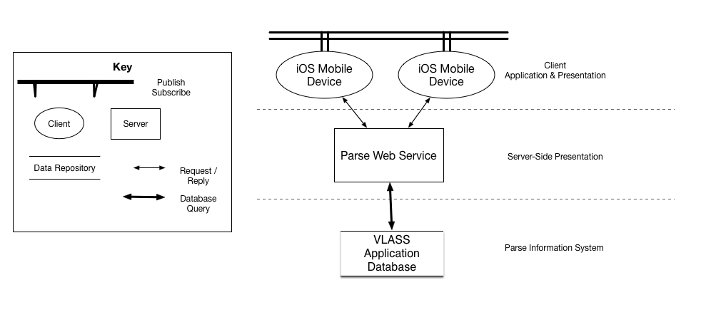

The Application and Presentation layer of VLASS contains many user interfaces throughout the application which are described individually in the detailed design. The users of the application interact with the UI through an iOS mobile device. This allows users to interact with the system through various forms such as: data input, data presentation, online discussions, viewing assignment details, and interacting with an instructor through polling. All of the data that is received as input or displayed dynamically is passed through Parse web service connection objects. This allows the application to store data about every user, course, assignment, grade, and file that is within the application. The application also utilizes the web service to allow concurrent users to view data dynamically and in real time. Any updates, changes, or deletions to data items can be seen across devices through the publish subscribe architecture among the users.

**Design Issues**

<Discuss your team's evaluation of issues such as reusability, maintainability, testability, performance, portability, reuse, safety, ... Which issues are relevant to your project? What prototypes (if any) will you need to do to evaluate alternate design strategies? What technical difficulties do you expect encounter? How will you solve them? What design trade-offs did you make in your selection of the architecture? What was your rationale for selecting this architecture? What technical risks are involved in this solution?>